NAIIS Web Application
User Manual
Version 2.0

Contents
1 Introduction 4
2 General information 4
2.1 System overview 4
2.2 Pending NAIIS features 5
2.3 Contact 5
3 Getting started 6
3.1 User Access, Roles and Privileges 6
3.2 How to access/ log out / create a GHG inventory 6
3.2.1 How to access the NAIIS application 6
3.2.2 Create, Start, Add new and View GHG inventory year 8
3.2.3 Initial screen / menu tab of the NFP, PM and SE 13
3.2.4 How to log out 13
3.3 User management 14
3.3.1 Add User 14
3.3.2 Disable/Enable User 15
3.3.3 View User 16
4 Using the system 17
4.1 Data Entry 17
4.2 Navigation tree 17
4.3 Grids 17
4.4 Data input 18
4.5 Add/delete new nodes – user defined source categories 18
4.5.1 Add new nodes 18
4.5.2 Delete nodes – user defined nodes 20
4.6 Backup of data files 20
5 Key Category Analysis 21
5.1 Using the default list 22
5.2 Customizing the list 22
5.3 Delete subnodes 23
6 Reporting Tables 24
7 Data Export/Import 25
7.1 Excel Export – Data Entry 25
7.2 Excel/XML Data import 26
7.3 Export reporting tables 27
7.4 XML Export 28
8 Completeness 30
9 Consistency 32
10 Submission management 34
10.1 Workflow 34
10.2 Start of inventory/submission (NFP or PM) 34
10.3 Send for checking (PM) 36
10.4 Send for approval/rejection of an Inventory (PM) 37
10.4.1 Send for approval of an Inventory 37
10.4.2 Rejection of an Inventory 37
10.5 Approval or Rejection of an inventory (NFP) 39
10.5.1 Approval of an inventory 39
10.5.2 Rejection of an inventory 40
10.6 Submit inventory (PM) 41
10.6.1 Submit select tables for preparing the general submission 41
Glossary of terms and abbreviations 43
Annex 1: Non-Annex I (NAI) Parties 44
Annex 2: Fuel categories 46
Annex 3: Global Warming Potentials (GWPs) 47
Annex 4: Default values 48

1 Introduction

The Non-Annex I Inventory software (NAIIS) web application is a web-based tool developed for use by Parties not included in Annex I to the Convention (non-Annex I Parties) to estimate and report their national greenhouse gas inventories (GHG inventories). As per Article 4, paragraph 1 (a), and Article 12, paragraph 1 (a) of the Convention, non-Annex I Parties are required to communicate to the Conference of the Parties a national inventory of anthropogenic emissions by sources and removals by sinks of all greenhouse gases (GHGs) not controlled by the Montreal Protocol, to the extent its capacities permit, following the guidelines contained in the annex to decision17/CP.8.

In order to assist non-Annex I Parties in estimating and reporting their GHG inventories as part of their national communications, the secretariat developed an Excel-based software which incorporated all the elements of a national GHG inventory prescribed by decision 17/CP.8. The software was based on the IPCC inventory software version 1.1, which used the Tier 1 methodologies for estimating GHG emissions and removals for all source categories included in the Revised 1996 IPCC Guidelines, and further complemented by the GPGs.

Since its release in 2005, most non-Annex I Parties have been using that software for the development of their national GHG inventories. In December 2011, Parties requested the secretariat to upgrade the software and make it available to non-Annex I Parties by June 2013. Pursuant to that request, the secretariat converted the current Excel-based version of the software (v.1.3.2) into a web-based application (NAIIS) which provides greater flexibility and security for maintaining data.

2 General information
The NAIIS is a web-based application designed to enable non-Annex I Parties estimate their national GHG inventories according to the UNFCCC guidelines and using the IPCC methodologies, and to report the results in their national communications and biennial update reports.

2.1 System overview
The NAIIS web application has the following functionalities:
- User management (only for the user roles NFP and PM)
- Submission management
- Data entry
- Key category analysis
- Reporting tables
- Data Export/Import
- Completeness
- Consistency

The NAIIS web application allows input of data through three different channels:
- Manual input into the entry grids
- Partial or full import of data from Excel
- Bulk import of data from XML
The GHG emissions totals, by gas and by sector, are automatically calculated and saved based on the values entered for activity data (AD), emission factors and other relevant parameters. In addition, the software facilitates the reporting of other category specific information, for example, the choice of the method for activity data and emission factors.

2.2 Pending NAIIS features

List of pending functionalities in NAIIS:
-----------------------------------------
1. Web services integration for help desk
2. Display of information in 5 remaining UN languages.

2.3 Contact
Requests for access to, inquiries on the use of the software, and comments on the design and functionalities of the application should be sent to the dedicated e-mail address naiisapp@unfccc.int.

3 Getting started

3.1 User Access, Roles and Privileges
The users of the application are the members of the national team(s) of non-Annex I Parties involved in the preparation of their national GHG inventories, and each user is assigned a role.
The table below explains the different levels of the access rights and corresponding explanation for each role. It is important to note that the roles are not necessarily identical to a person’s title (e.g. National Focal Point) and that a person can take on several roles (which may be necessary for some countries).
There are three types of access rights (roles) to the NAIIS application:
Type of access rights for specific roles | Process to gain access rights
National Focal Point (NFP): Will be responsible for identifying the members of the team and is the only one who has the right to approve the submission of any GHG inventory.  NFPs will have the option to create, edit, update or delete all of their country’s GHG data entries, and grant access rights to the ‘Project manager’ and 'Sectoral experts' for their country if they choose. | Parties that have not already requested and received access rights can obtain them by having their National Focal Point contact: naiisapp@unfccc.int  (Note: Some Parties may have more than one individual acting as the NFP; however the system can accommodate only one account per Party).
Project Manager (PM): Will have the right to enter/edit data in all sectors, as well as to generate an official submission to the UNFCCC, and grant access rights to the 'Sectoral experts' for their country. | Entities will be provided these rights by their NFP. If a Party decides to grant access to a PM, their NFP will be able to create such user account on the NAIIS application.
Sectoral Experts (SE): Will have the right to enter/edit data in respective sector(s). | Experts will be provided these rights by their NFP and PM. If a Party decides to grant access to Sectoral Experts, the NFP will be able to create such user accounts and assign them in respective sector(s).

Access for the NFP will be provided by the secretariat, upon request; however, the accounts of the other users within the country shall only be created by the NFP.

3.2 How to access/ log out / create a GHG inventory

3.2.1 How to access the NAIIS application
Open any internet browser (i.e. Internet Explorer, Firefox, etc.) and type in the following URL http://unfccc.int/7627 on the browser’s address bar. (figure 1 and figure 2)
Figure 1. Using Internet Explorer browser
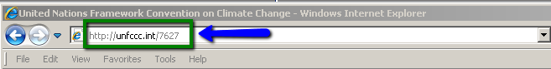

Figure 2. Using Firefox browser
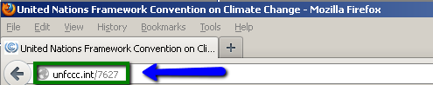

Press the ‘Enter key’ and the non-Annex I Greenhouse Gas Inventories web page appears.

To access the NAIIS application, click on the image NAIIS Web Application, the right hand side of the screen. (figure 3, number 1) and the log-in page will be displayed. (figure 4)

Figure 3. UNFCCC non-Annex I Greenhouse Gas Inventories web page
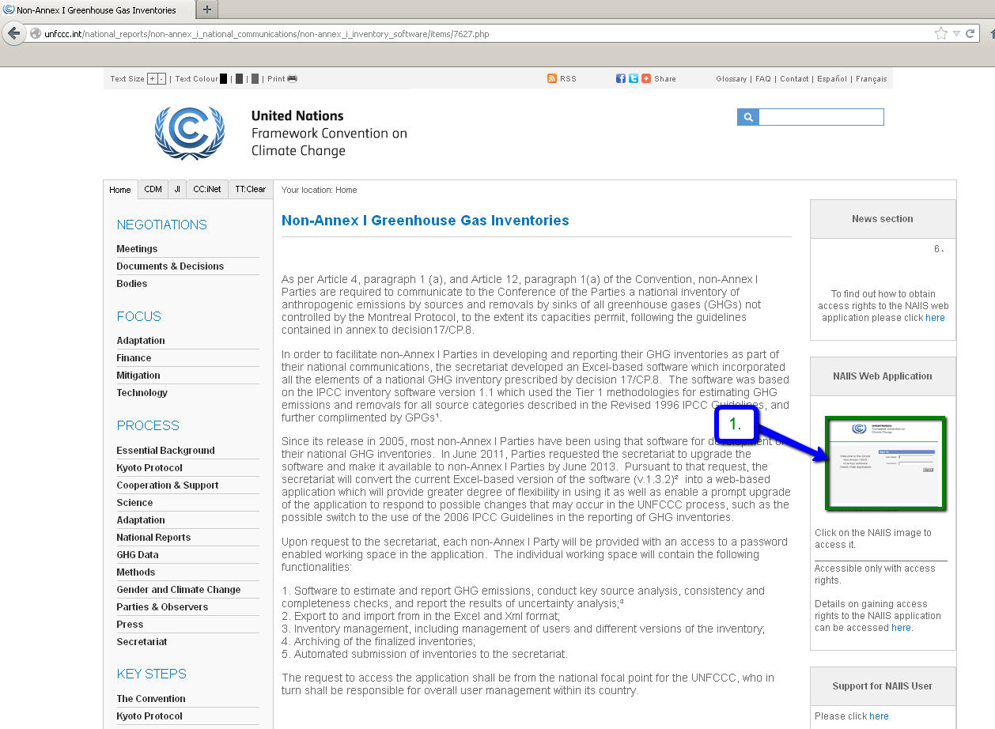

Figure 4. Login page of the NAIIS Web Application
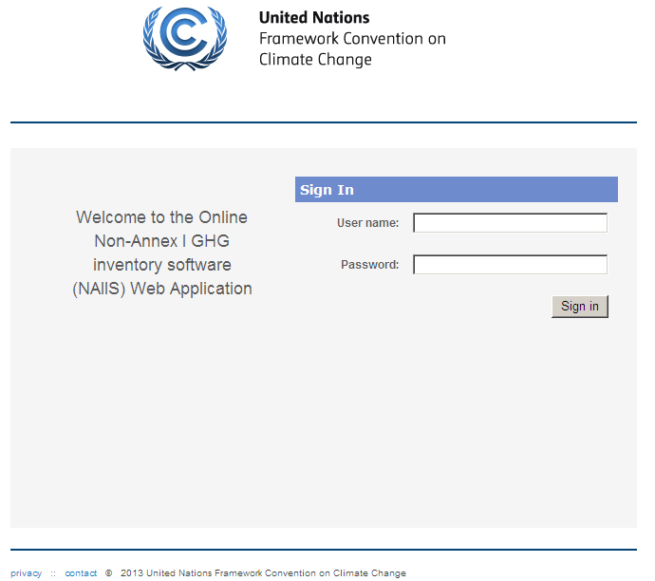
To log in, enter the username and password and click on the “Sign in” button.

3.2.2 Create, Start, Add new and View GHG inventory year

These functions allow the NFP and PM to create or edit a GHG inventory to the NAIIS software.

3.2.2.1 Create a new or Start a GHG inventory year

3.2.2.1.1 Create a new GHG inventory

Note: This step can ONLY be undertaken by the NFP or PM !

In order to create one or several GHG inventories, the following steps can be done by the NFP or PM:

- Log in as NFP or PM
- Hover the cursor on “Submission Management” menu and click on the “View Inventories Progress” button. (see Figure 5). Left click on the “+” sign will create a new GHG inventory. (see Figure 6)

The new GHG Inventory name will be automatically generated by the NAIIS system, as follows:
<Name of the Non-Annex I Party>_<Year in 4 digits>_<version no.>_ Inventory
For example: Paraguay_2013_1_Inventory or Bhutan_2014_2.1_Inventory

Figure 5. Create new GHG inventory screen
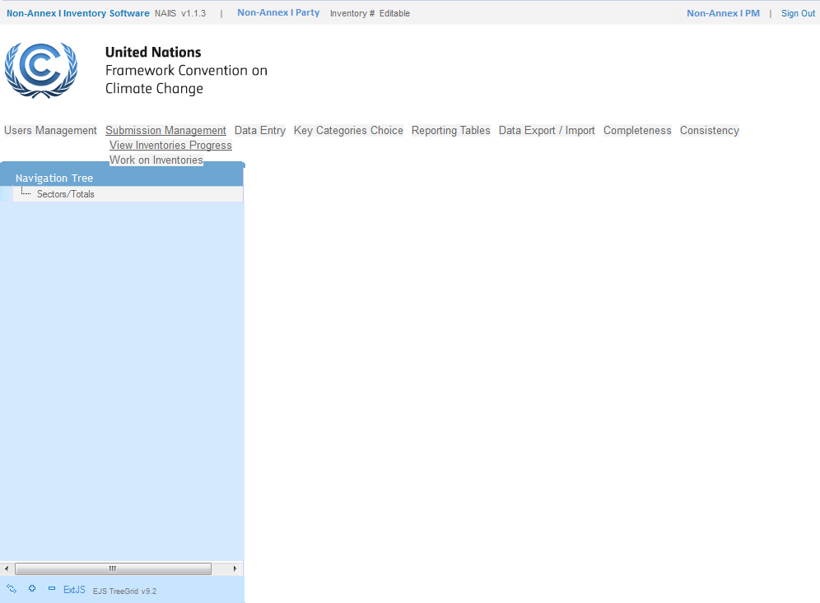

Figure 6. New GHG inventory created screen
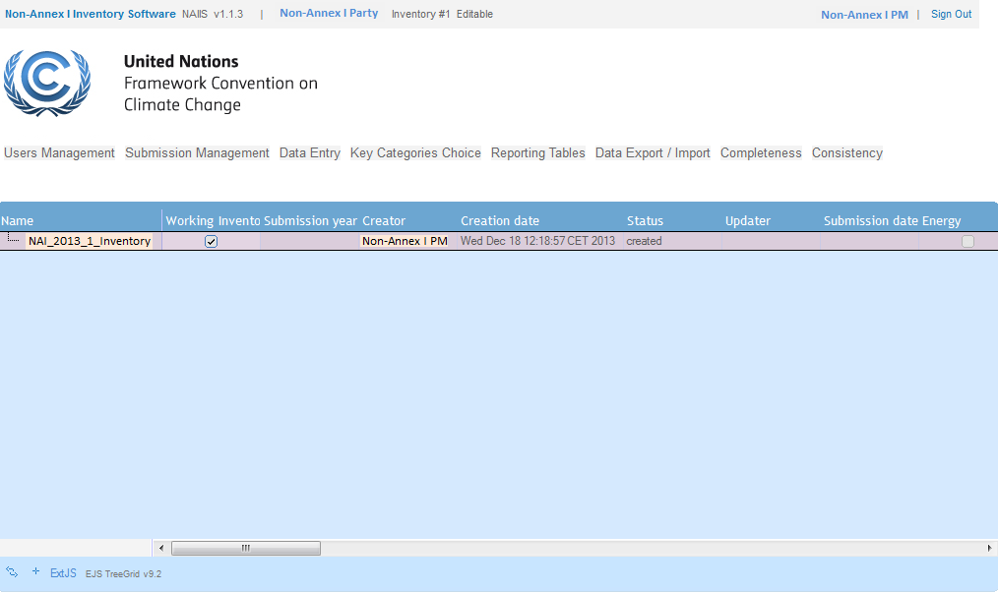

Start a GHG inventory

In order to START a GHG inventory, please follow the steps below:
- Log in as PM.
- Hover the cursor on the “Submission Management” and click on the “View Inventories Progress” button.
- Click/select the appropriate GHG Inventory in Status = “created” (see figure 7a).
- Click on “Work on Inventories” under Submission Management (see figure 7b).
Figure 7: Select an Inventory screen
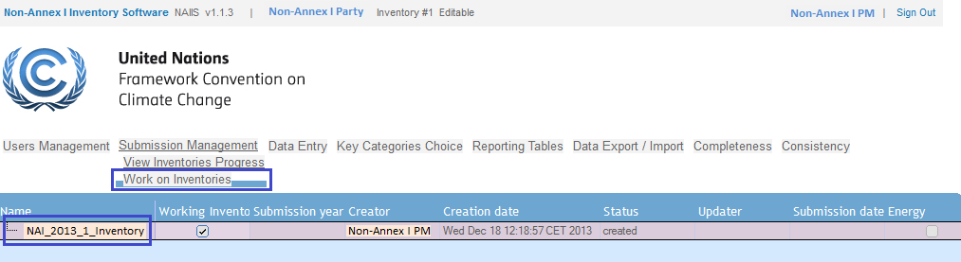
a
b

- Left click to select the appropriate Inventory (figure 8a)
- Press the “Start Inventory” button (figure 8b)
Figure 8: Start an Inventory screen
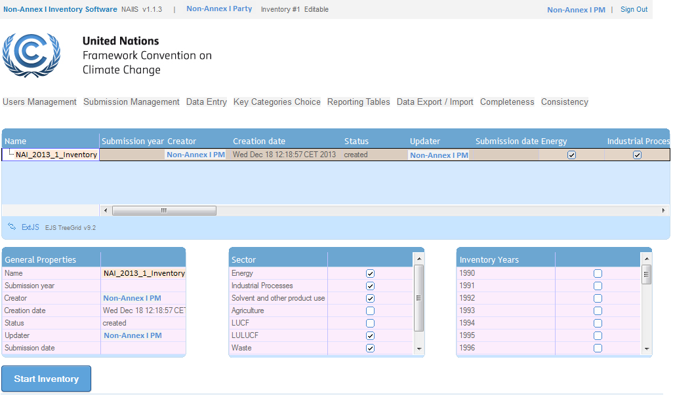
b
a
Once the “Start Inventory” button was pressed, the status of the selected Inventory change to “started”. (see Figure 9)
Figure 9: “Started” status of an Inventory
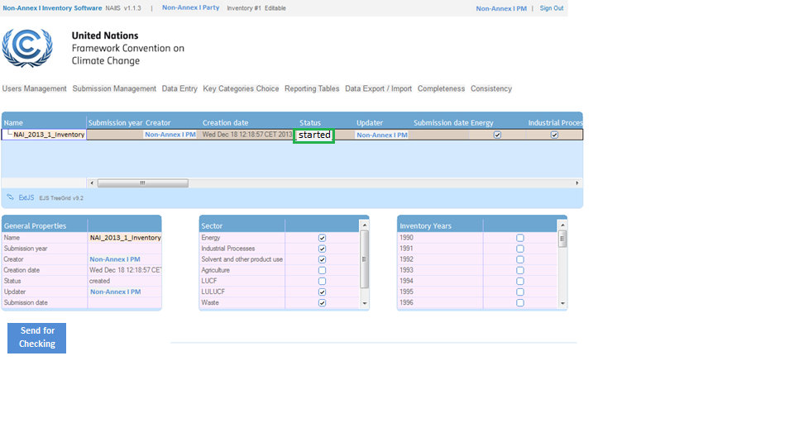
a

3.2.2.2 Add a new GHG inventory year or edit general properties/sectors (only NFP and PM’s)
- Log in as NFP or PM.
- Click on “Work on Inventories” under Submission Management (figure 10).

Figure 10: Sub menu “Work on Inventories”

Once the “Work on Inventories” has been clicked, the initial screen will be displayed, which shows the following boxes (figure 11):
- Existing Inventory (with all options)
- General properties – include the name, submission year, creator, creation date, status, updater and submission date
- Sectors
- Inventory years

Figure 11. Initial screen of “Work on Inventories”
c
d
b
a

Follow the steps to add/remove an inventory year:
- Click on the inventory year (figure 12a)
- Select the inventory year under General properties (figure 12b)
- Select or deselect the appropriate Sectors (figure 12c)
- To add or remove an inventory year, select or deselect the relevant year under Inventory Years box (figure 12d)

Figure 12. Screen of “Work on Inventories”
d
c
b
a

3.2.2.3 View Inventory Progress
- The NFP or PM should log into the system.
- Click on “View Inventories Progress” under Submission Management (figure 13)

Figure 13. View Inventories Progress
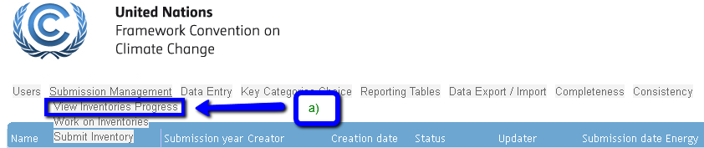

Click on “View Inventories Progress” button will display the initial screen with the following columns (figure 14a, 14b and 14c):
- Name - automatically given by the system, once created
- Working Inventory – active box shows the current working inventory
- Submission year – year when the submission process was initiated
- Creator – user who created the inventory
- Creation date – inventory creation date
- Status – created, started, check, submitted, approved, awaiting approval, awaiting rejection check
- Updater – user name who updated the inventory
- Submission date – date of submission
- Sectors – Energy, Industrial processes, Solvent and other product use, Agriculture, LUCF, LULUCF, Waste, Other
- Inventory year

Figure 14a. Example of Initial screen of View Inventories Progress
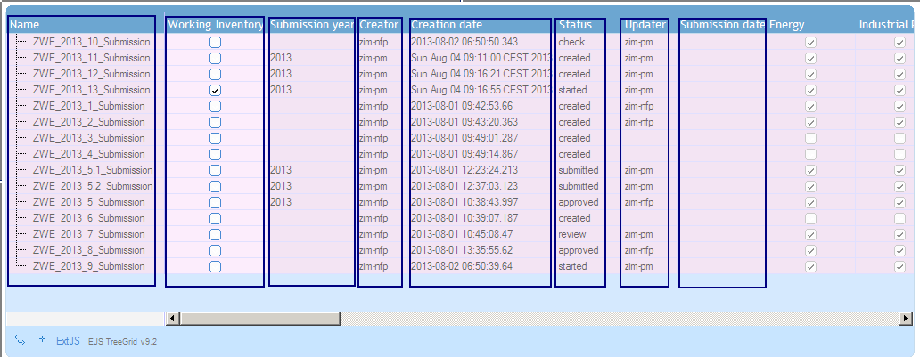

Figure 14b. Example of Initial screen of View Inventories Progress
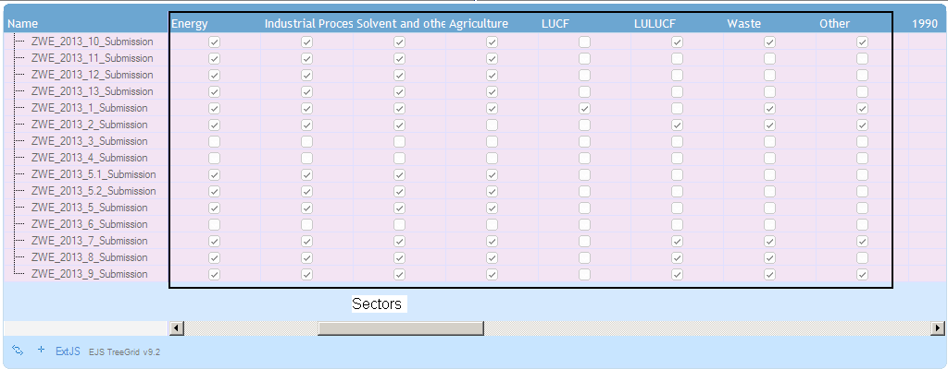

Figure 14c. Example of Initial screen of View Inventories Progress
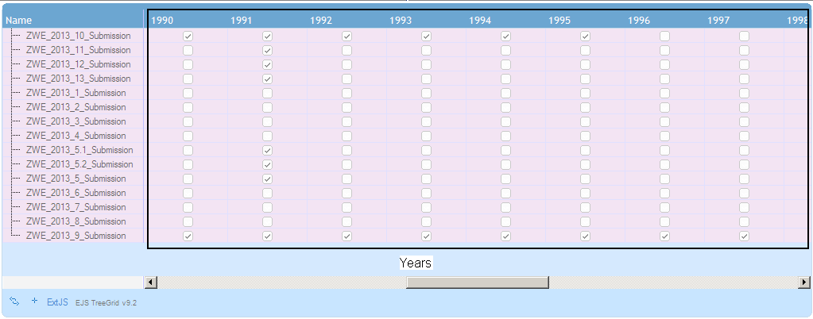

3.2.3 Initial screen / menu tab of the NFP, PM and SE
Once the NFP, PM or SE logs-in, the initial screen with multiple tabs will be displayed which feature different functions. Click the name of the tab to enter.
Initial screen / menu tabs of NFP’s and PM’s:
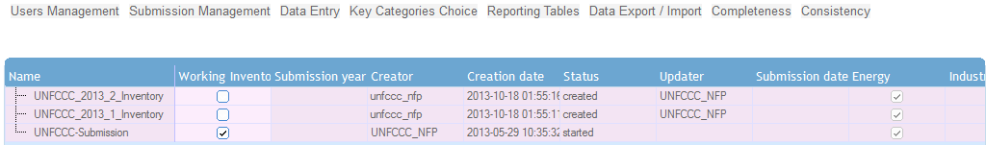

Menu tabs for SE’s
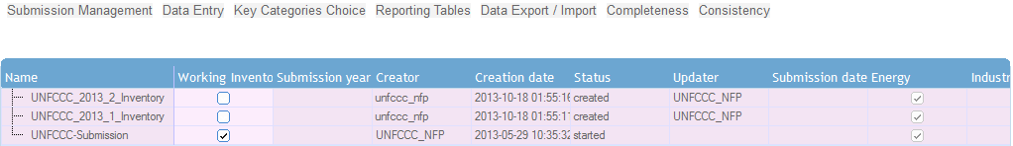
Note: Once a user logs in, the initial screen is the Submission Management screen of the Non – Annex I Party

3.2.4 How to log out
To log out, click on the link to “Sign out” located at the upper right corner of the page. (Figure 15)
Figure 15. Sign out screen
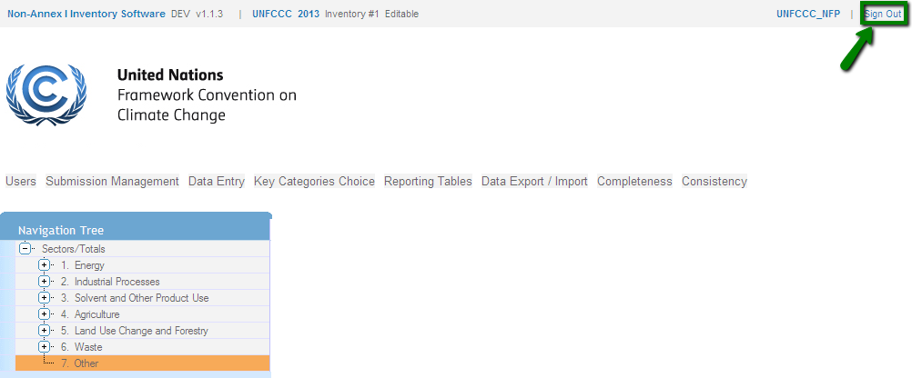
When you have successfully logged-out of the system, the screen below (figure 16) will be displayed.
Figure 16. Sign out screen
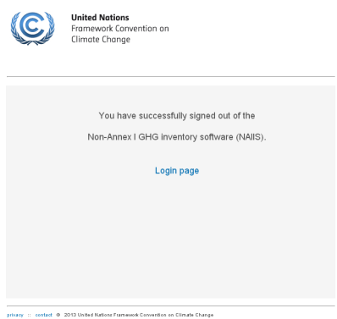

Note that after 20 minutes of inactivity, the session is automatically timed out and an error message will be displayed (figure 17). In such cases, either click on “Sign out” and log in again, or click on any of the links to be redirected to the log in page.

Figure 17. Fatal error
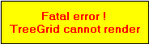

3.3 User management

3.3.1 Add User

Note: This function is ONLY available for NFP’s and PM’s!

- Log in as NFP or PM
- Hover the cursor on the “Users Management” tab and click on the “Users Administration” button. (see figure 18); this opens the Users Administration screen (figure 19).

Figure 18. Users Administration

Figure 19. Initial screen of Users Administration
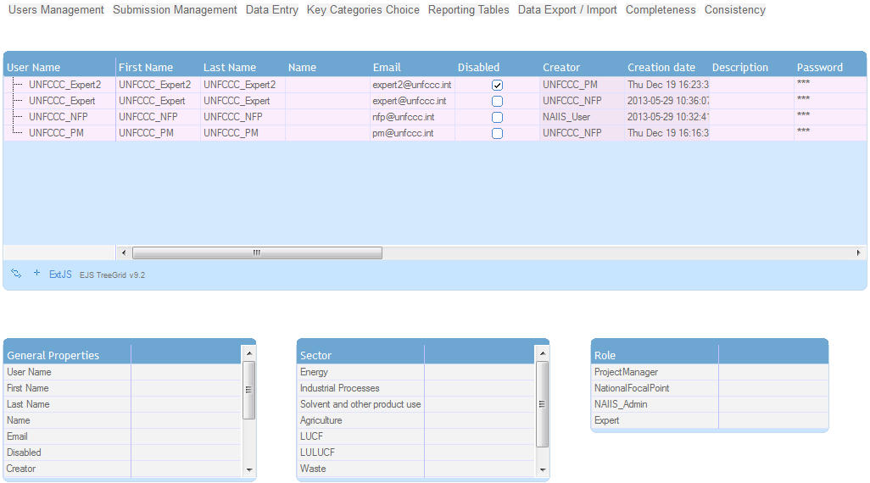
a

- Click the “+” sign (figure 19a) creates a new user (figure 20 new User).
- Double click on the cell of the newly created user name and enter a new user name (must be unique and contain at least 3 characters).
Once changed, press the enter key and the new user name will be saved in the respective table of the NAIIS database.

Note: New user name(s) will be generated by the system as default [Non-Annex I Party name] + “newUser”
(i.e. UgandanewUser, PhilippinesnewUser, ArgentinanewUser)

Fill-in User Information

There are two options to fill in the information of a new user by entering the data

(a) on the same row of the new user (figure 20a) or;
(b) in the General Properties, Sector and Role boxes (figure 20a, 20b and 20c).

Figure 20. New user created screen

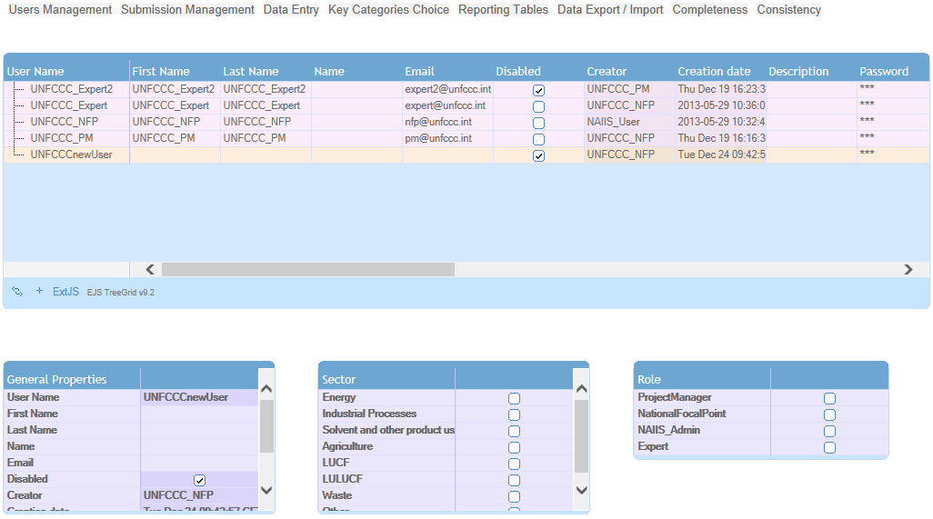
a
new User
d
c
b

Fill in the following fields:
- First Name
- Last Name
- Name (optional)
- Email address
- Password (must have 1 capital letter, 1 numeric and 8 characters long)
- User Role
- Sectors
- Change password (tick the box prompts the user to change his/her password)

The functionality to change password is not fully implemented in this release. Please do not to tick the “Change password” box under General Properties! (See figure 20 b).

- Enable user (Proceed to section 3.3.2 Disable/Enable User)

3.3.2 Disable/Enable User

This function allows the NFP and PM to activate and/or de-activate users of their country.

- Log in as NFP or PM
- Hover the cursor on the “Users Management” tab and click on the “Users Administration” button. (see figure 21); this opens the Disable/Enable User screen (figure 22).

Figure 21. Users Administration

3.3.2.1 Enable User
On the Disable/Enable screen, search for the user whose account should be activated and
un-tick the ‘Disabled’ box. (figure 22a).

3.3.2.2 Disable User
On the Disable/Enable screen, search for the user whose account should be de-activated and tick the ‘Disabled’ box (figure 22a).

Figure 22. Disable/Enable User screen

a

3.3.3 View User

This function enables NFP and PM to view all users of their country.

- Log in as NFP or PM
- Hover the cursor on the “Users Management” tab and click on the “Users Administration” button. (see figure 21); this opens the Users Administration screen (figure 22).

Figure 21. Users Administration

- Click on the row of the respective user to be viewed (figure 22a). All information of the selected user will be displayed on the General Properties, Sector and Role boxes (figure 22b).

Figure 22. Users Administration
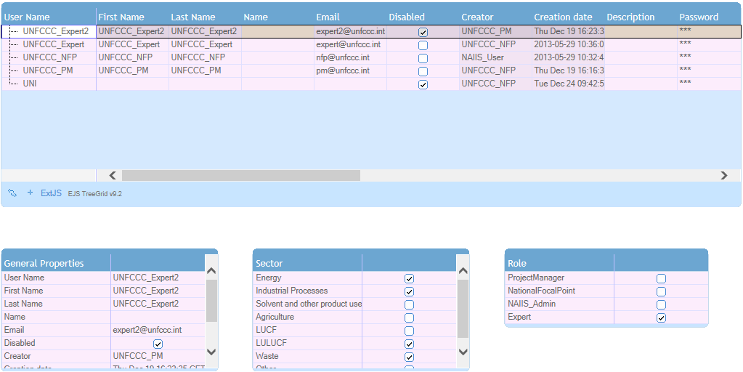
b
a

4 Using the system
This section provides a description of the various functions of the system represented by each tab indicated in section 3.2.3 above.

4.1 Data Entry
The data entry tab provides the function to input data into the system through the use of grids. To display the grid, a node has to be selected from the navigation tree. (Figure 23)

4.2 Navigation tree
To expand or collapse the tree, click on the or signs in front of the nodes, respectively. You can also expand or collapse the entire tree by clicking the plus and minus signs at the bottom of the tree.

Figure 23. Functions of the navigation tree
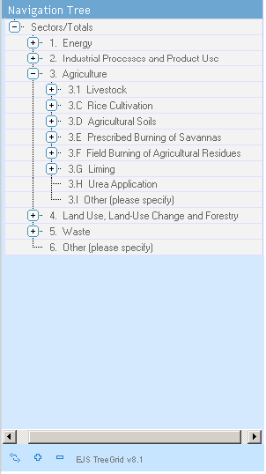
Expand or collapse all rows of the navigation tree
Collapse the selected node
Expand the selected node

4.3 Grids
Each node on the navigation tree has a corresponding grid.
A grid includes elements required for reporting information such as activity data, other relevant information, and emissions/removals data.

The cells in the grid have different colors. White grid cells denote that the user can enter data, green cells mean that the data is automatically calculated by the NAIIS application, light blue cells signify that data are automatically copied from a different node (for example in 1.B.1.a.1.i), and yellow cells mean that a default value (for example, fraction of carbon stored in reference approach) is provided. Where the cell is grey, no input is necessary. (figure 24)
In the energy sector, users are provided a dropdown list to select a unit in reporting the consumption and production of fuels. This is marked with.
User can select the unit by clicking the down arrow , then the drop down menu opens

Figure 24. Functions in a grid
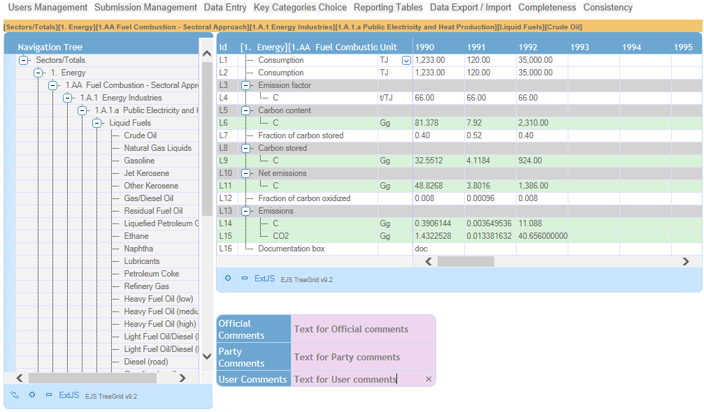
User can provide Official, Party or User comments
Users enters data
into white cell

4.4 Data input
Data can be entered into the white grid cells only. It is also possible to copy and paste data from one cell to another by using the shortcut keys ‘Ctrl + c’ to copy and ‘Ctrl + v’ to paste. Each value entered is automatically saved. When the data is entered, it is first shown in bold, and then changes to normal font indicating that the value has been saved. Saving occurs immediately (usually within 1 second), but in case the system becomes slower, the user should wait until data are shown in regular font before exiting the grid. Otherwise, the data entered will not be saved.
As mentioned in the previous section, default values are provided for some parameters (yellow cells in the grid). These values can be overwritten if the Party has more accurate data.
Note: Data that has been entered will be automatically saved.

4.5 Add/delete new nodes – user defined source categories

4.5.1 Add new nodes
New nodes for example, can be added to the navigation tree in order to add either a category, a fluorinated gas (F-gas), a fuel, a livestock type, or a subdivision in the LULUCF sector.
User-defined items can be added for:
- Categories indicated as “Other (please specify)”
- LULUCF subdivision
- User-defined fuels
To add a new child node, either a pre-defined or a user-defined item, click on the right mouse button on the parent node and select “Add new child node”. For ease of use, the parent nodes where a child node can be added are highlighted in orange (figure 25).
Figure 25. Add new child node
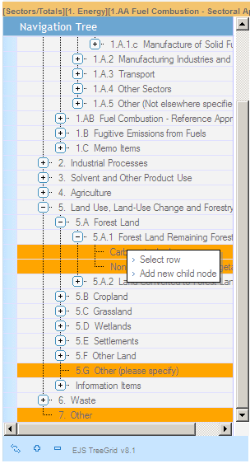

4.5.2 Delete nodes – user defined nodes

Only user-added nodes can be deleted. To delete a node, right-click on the node and select “Delete child node” (figure 26). When deleting user-defined nodes, each of the child nodes has to be deleted first before deleting the parent node that was added. If a user accidentally deletes the parent node before deleting child nodes, an error message is displayed, and the nodes will disappear from the tree. However, the nodes are not removed from the database, therefore the user has to click on the “Reload grid” icon () located at the bottom of the navigation tree. After doing so, the child nodes will re-appear on the tree. It should be noted that any data entered in the grid corresponding to the user-added nodes are also deleted from the database once the nodes are removed.

Figure 26. Delete node

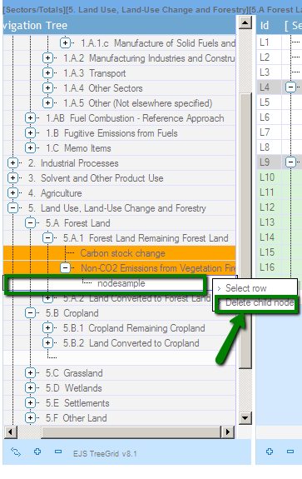

4.6 Backup of data files
To create a backup of your data, you can export the data files and save them as Excel files. Please use the Excel Export function. (Section 7.1)

5 Key Category Analysis

This functionality allows the user to identify and select one of the categories to be used for performing the Key Category Analysis (KCA). Upon selection of the category, the system will perform both level assessment and trend assessment for which the data are available. The corresponding results of the assessments are available in the reporting tables.
The selection of one or several categories is undertaken as follows. When pressing the ‘Key Categories Choice’ on the top main menu bar, on the left hand side, select the KCA Year to be used, the navigation tree displays all sector nodes with the following columns (figure 27):
- Description
- Gas
- Percent of Total
- Default List
- Top 95
- Important
The user will have the option to use the default list or customize it. (see figure 27)
Figure 27. Key Categories Choice main screen
a
b
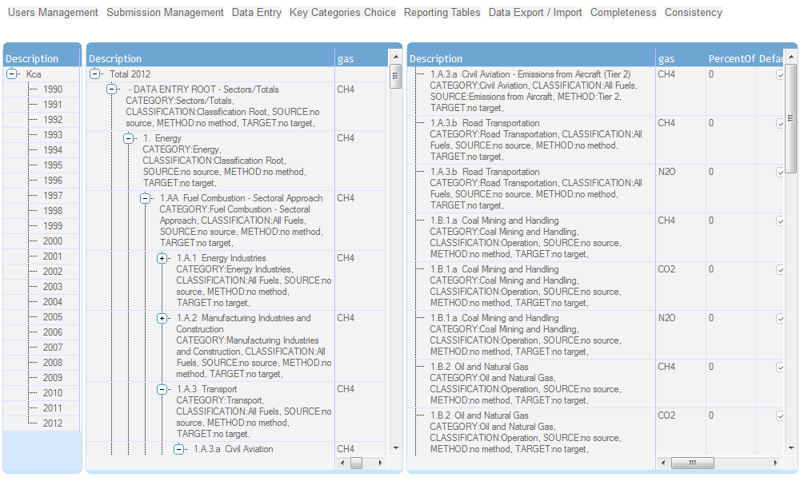
d
c

5.1 Using the default list
If the NFP, PM or SE decides to use the default list, they can proceed to the Reporting tables directly. (Section 6 Reporting Tables).

5.2 Customizing the list
To add a key category, click on the specific node or line (figure 28, number.1), then reload the list
Figure 28. Key Categories Choice screen
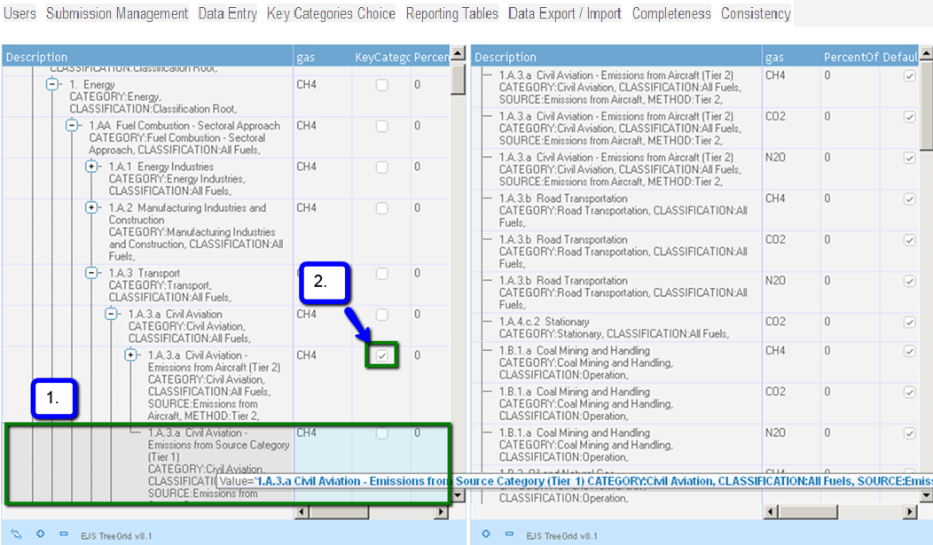

Once the list has been reloaded or refreshed, as per example below, the node 1.A.3.a Civil aviation – Emission from Aircraft has been selected (figure 29, number 1), and the parent node 1.A.3.a Civil Aviation has been unselected. (figure 29, number 2).
Figure 29. Key Categories Choice screen
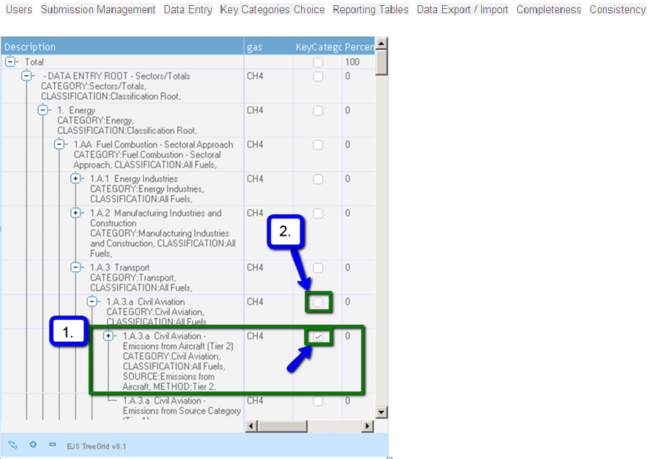

5.3 Delete subnodes

To delete subnodes, double click on the specific subnode or line (figure 30, number.a), a pop-up window warning message opens. (See figure 31).
Press the “Ok” button to delete the sub node or the “Cancel” button not to delete. (see figure 31 a)
Figure 30. Key Categories screen – delete subnodes

a

Figure 31. Key Categories – Delete confirmation screen
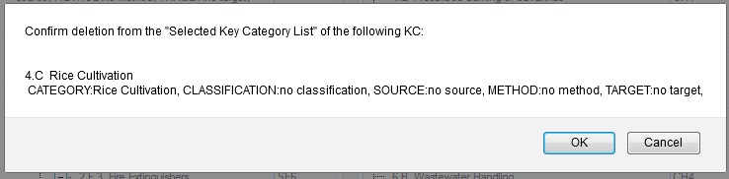
a

6 Reporting Tables

The Reporting Tables enable the user to view the data entered in the grids under the Data Entry section of the web application. Note, however, that the column headings are not always fully displayed in the tables because column widths are fixed. The full heading can be seen by scrolling the mouse over the column title.
The navigation tree here is organized by year (figure 32). It functions similarly as the navigation tree for data entry. Data in reporting tables cannot be modified; modifications to data should be done through the data entry grids.
Figure 32: Reporting tables organized by year
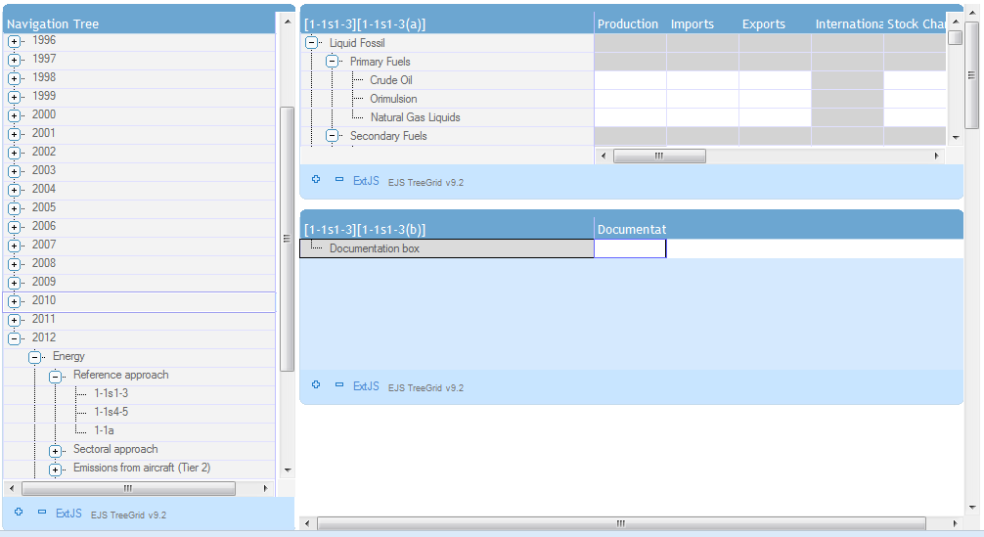

7 Data Export/Import

This function enables users to export data from the system in either Excel or XML format.

7.1 Excel Export – Data Entry

Click on the “Data Export / Import” tab and the navigation tree will appear on the left-hand side (figure 33).

Figure 33: Data Export / Import initial navigation tree
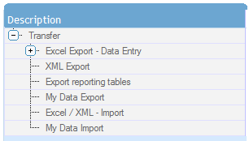

There are three options available to export files:
- Export selected single grid – only the data of the current selected grid will be exported. (figure 34, d)
- Export selected sector / subsector– all data of the current selected grid and the sub sectors will be exported. (figure 34, e)
- Export all data entry grids – all data entry grids will be exported. (figure 34, f)

Clicking on one of the Sector’s or sub sectors’ (figure 34, a) or c)) on the left-hand side navigation tree, three Export buttons will appear on the middle of the screen. (figure 34, b)

Click on one of the “Export” button. The system will then generate an excel export file.
The file that has been exported can be seen under “My Data Export” (figure 35).

Figure 34: Excel export
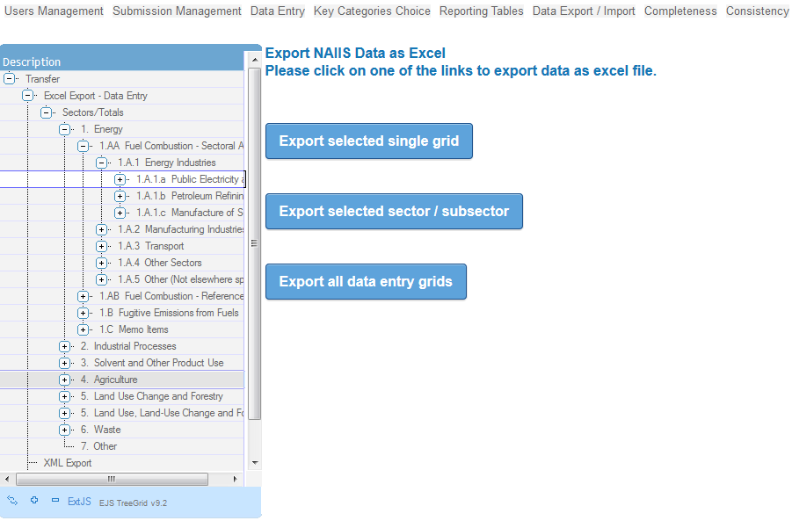
a
b
c
f
e
d

Figure 35: My Data Export
c
b
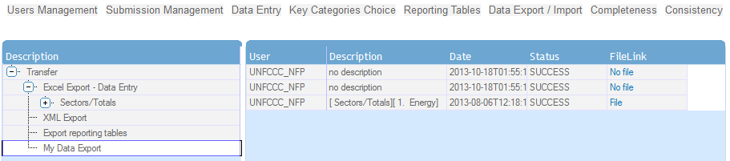
a

The user will be able to open or save the file by clicking on the FileLink “File”. (figure 36)

Figure 36: Export to Excel screen – Download file
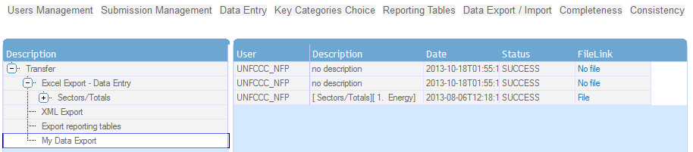

7.2 Excel/XML Data import

The data import tab allows the user to import data into the system with the use of an XML or Excel file.
To import data, click on the “Browse…” button (or “Choose file” for Chrome users), select the file to be imported, and then click on the “Submit” button (figure 37). A message will be displayed to confirm successful completion of import (figure 38). If the type of the file selected for import is incorrect, an error message is displayed (only *.xml and *.xlsx files are allowed).
Figure 37. Data import
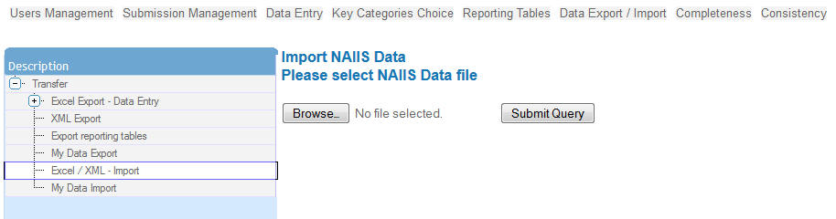
Click to select a
file to import
Click to import selected file
a

Pressing the “Submit Query” button will start the data import process.
On the left-hand side navigation tree, click on ‘My Data Import’ which opens a list of imported data.
The status of the import process can be seen under “My Data import” (figure 38,b).

Click on the “File” at column FileLink to open or save the file imported.

Figure 38. Download file screen
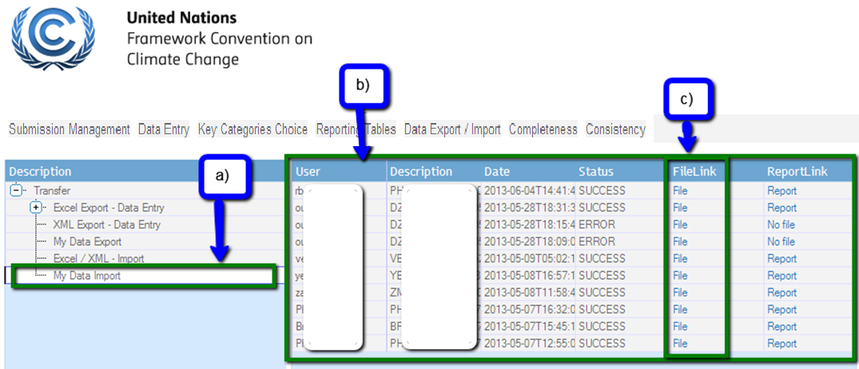

7.3 Export reporting tables
This Export report tables function allows the user to export reporting tables in excel file format.
Clicking on the “Export report tables” button triggers the system to generate an excel file (figure 39 c) and the following message appears on the screen:
‘We have received your request for reporting tables export. Please be patient, this may take a few minutes. You can check progress of export in ‘My Data Export’. (figure 40 a)

Figure 39. Export reporting tables screen

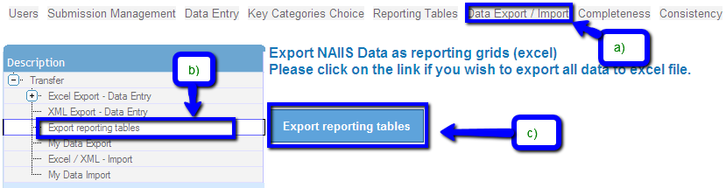

Figure 40. Export reporting tables screen
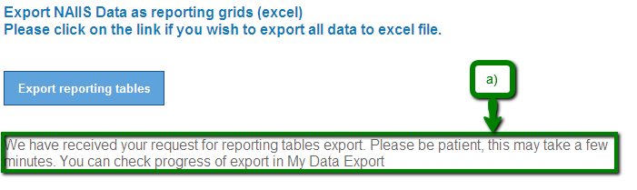

On the left-hand side navigation tree, click on ‘My Data Import’ which opens a list of imported data.
The status of the import process can be seen under “My Data import” (figure 41,b).

Click on the “File” at column FileLink to open or save the file exported.

Figure 41. My Data Export screen

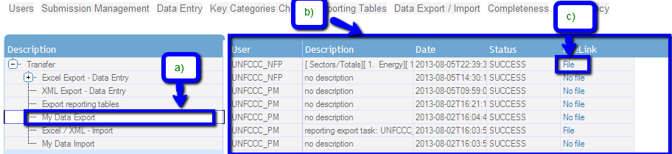

7.4 XML Export
This XML export function allows the user to export files in XML formats.
Clicking on the “XML Export – Data Entry” button triggers the system to generate an XML file (figure 42) and the following message appears on the screen:
‘We have received your request for xml file export. Please be patient, this may take a few minutes. You can check progress of export in ‘My Data Export’. (figure 43)

Figure 42. Export/Import navigation bar – XML Export – Data Entry
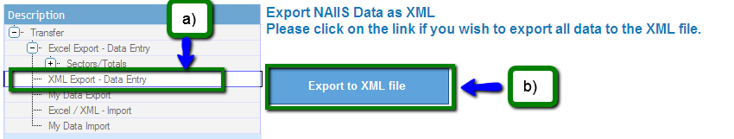

Figure 43. XML file export – message XML export file request

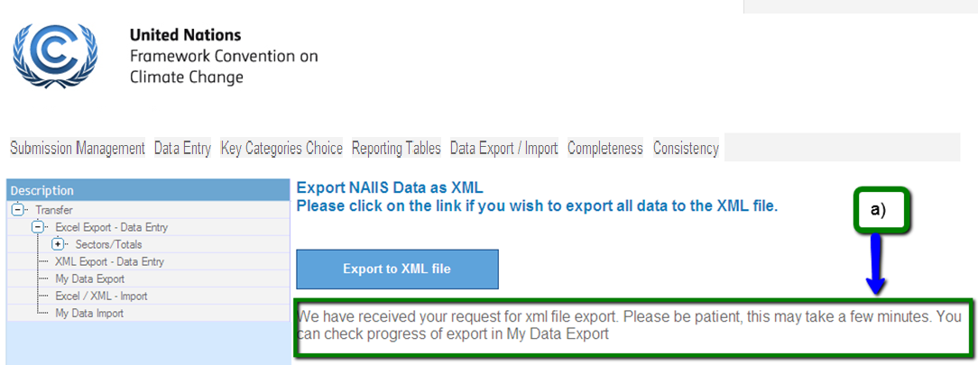

On the left-hand side navigation tree, click on ‘My Data Export’ which opens a list of export data. (figure 44,b)
User should be able to download the file by clicking on the “File” link. (figure 44,c)

Figure 44. Data Entry Grid Export to Excel screen
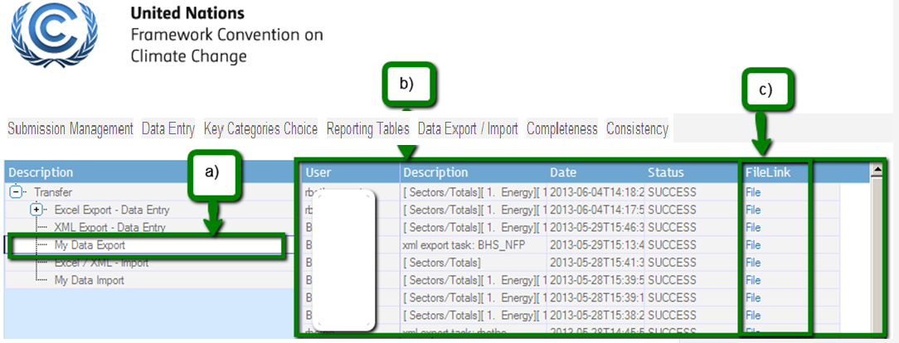

8 Completeness

This function allows the user to check whether all the grids of an inventory year have been completed.
When pressing the ‘Completeness’ tab on the top main menu bar, a navigation tree is displayed on the left-hand side, sorted by inventory years and then by sectors (nodes and sub-nodes)
Clicking on the specific nodes (figure 45, no.3) on the tree opens on the right-hand side the data entry grid for that node.

Figure 45 . Completeness screen

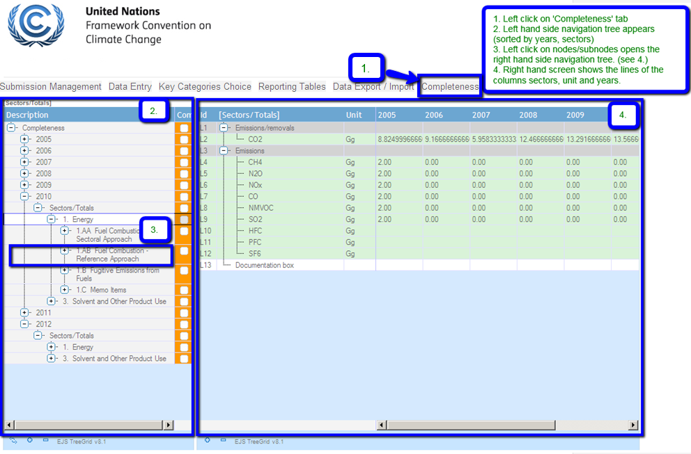

When all of the grids in a year or a sector are fully populated, the color of the checkbox under the column ‘Complete’ will be green. If only some of the grids are populated, the checkbox appears orange; if none of the grids are populated, it is highlighted red. (figure 46)
Figure 46. Completeness screen – Example
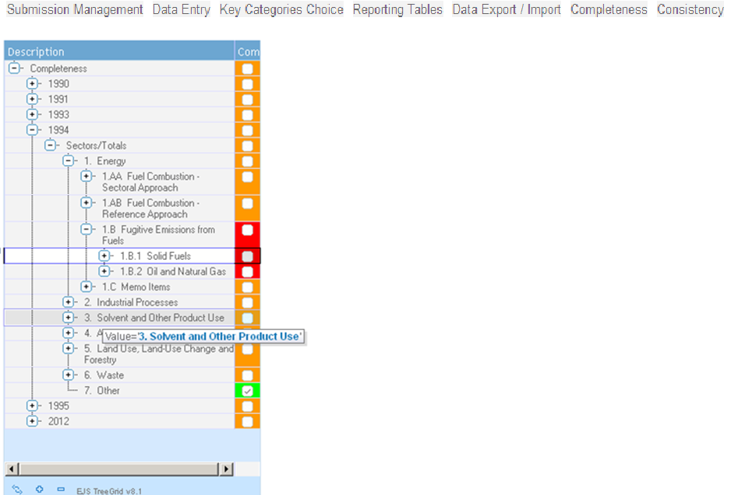

9 Consistency

Consistency is the function enabling the user to recalculate all the values of a given year, i.e. when the formulas have changed.
When pressing the ‘Consistency’ tab on the top main menu bar, the left-hand side navigation tree displays the inventory years in ascending order.
Clicking on the appropriate inventory year (figure 47, no.3) displays on the right hand side the recalculated data, if any.
Figure 47. Consistency initial screen

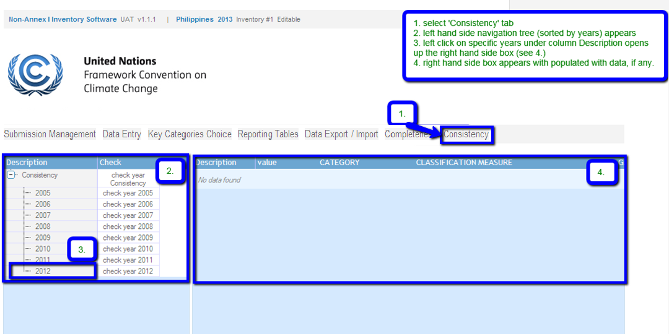

Press the corresponding year button to be checked. (figure 48, number 1). However, please note that the system is recalculating all the values for the selected year and a pop-up window with the message “Loading data” appears in the middle of the screen. (figure 49)

Figure 48. Consistency - example
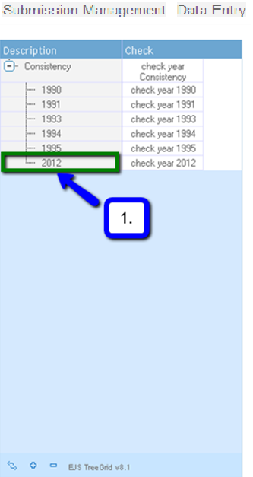

Figure 49. Consistency screen – message “Loading data”
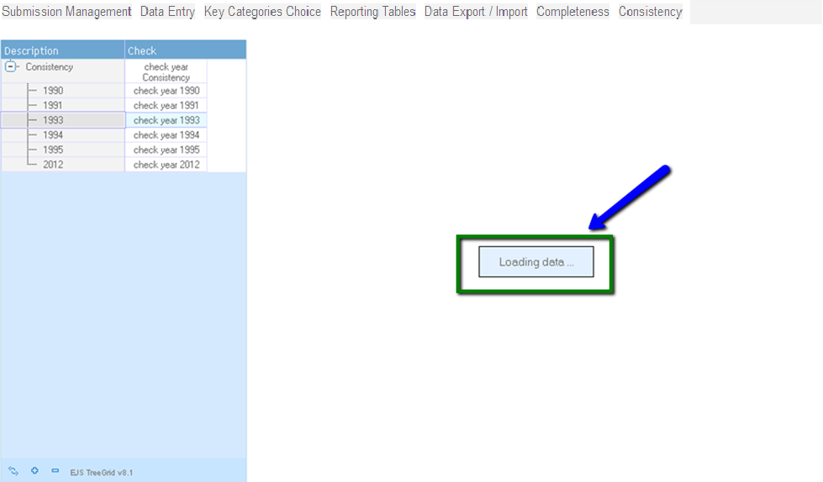

If no data has changed after the recalculation, the message “No data found” will appear on the screen (figure 50), otherwise a list of calculated data sorted by order of calculation will be displayed on the right hand side box. (figure 51)

Figure 50. Consistency screen – message “No data found”
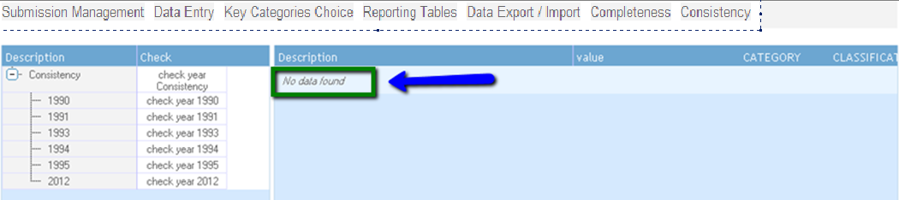

Figure 51. Consistency screen – list of calculated data
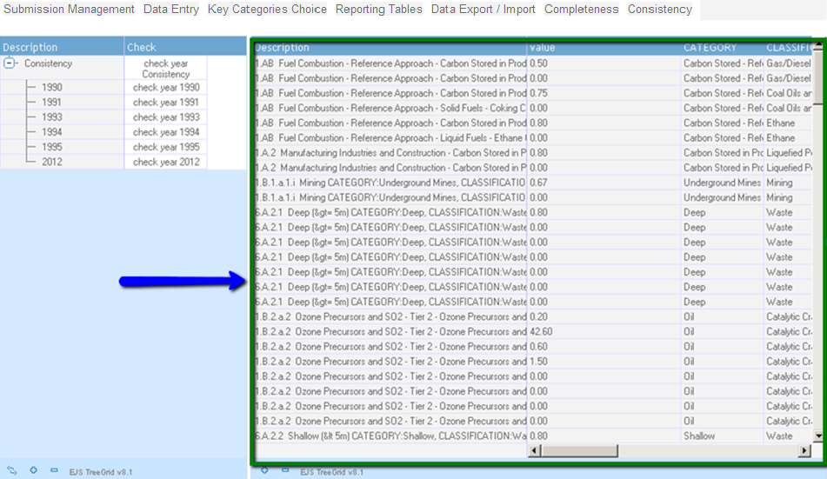

10 Submission management

10.1 Workflow

Creating and preparing an inventory, generating tables for checking by the NFP and approving and/or rejecting submission, follows a number of steps known collectively as a workflow. This chapter describes the workflow relating to the submission of the GHG inventory/(ies), which users should follow to create, prepare, and send GHG inventories for checking, and approval/rejection of the submission, within the NAIIS software. (figure 52)

Figure 52: Non-Annex I Inventory Software workflow

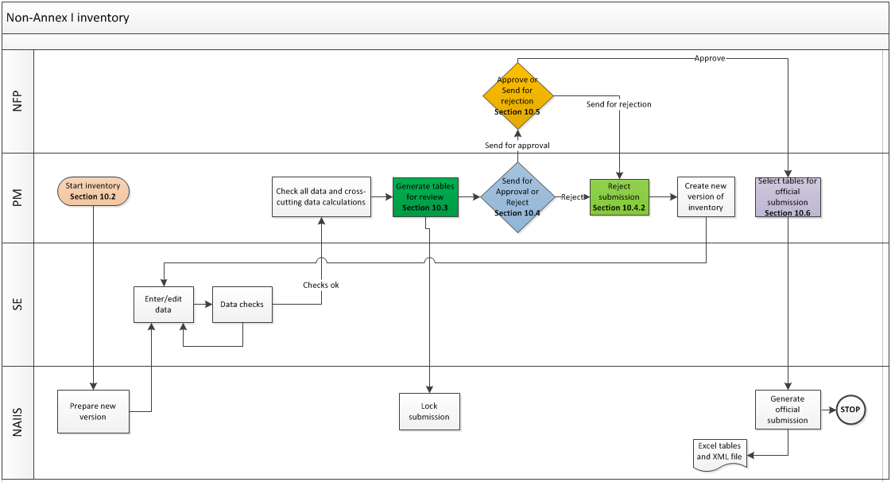

10.2 Start of inventory/submission (NFP or PM)

This procedure allows the NFP or PM to start a new (created) inventory. The existing data for the inventory year identified will be made available in the new inventory/submission.

These are the steps to start a new inventory:

- Click on “View Inventories Progress” under sub menu “Submission Management” (figure 53).

Figure 53. View Inventories Progress sub menu

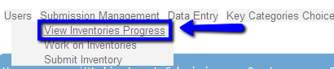

- The “View Inventories Progress” screen appears (figure 54).
- Select the appropriate inventory by clicking the box under column “Working Inventory” (figure 54a).

Figure 54. View Inventories Progress screen
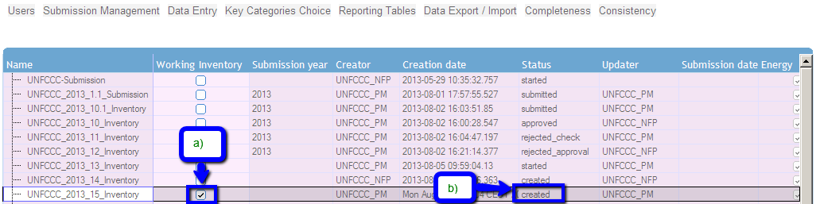

- Click on “Work on Inventories” under “Submission” (figure 55).

Figure 55. Work on Inventories sub menu
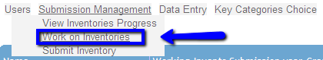

- Click the appropriate Inventory year on “Work on Inventories” under “Submission” (figure 56a).
- Press the “Start Inventory” button to start the inventory (figure 56a). Once pressed, the status changes to “started” (figure 57).

*** Once the “Start Inventory” button has been pressed by the NFP or PM, a notification email will be sent to all SE’s with the information that a new inventory was created. SE’s and PM’s can start entering their data into the NAIIS software. More details on how to do the data entry please see section 4.1.

Figure 56. Work on Inventories screen

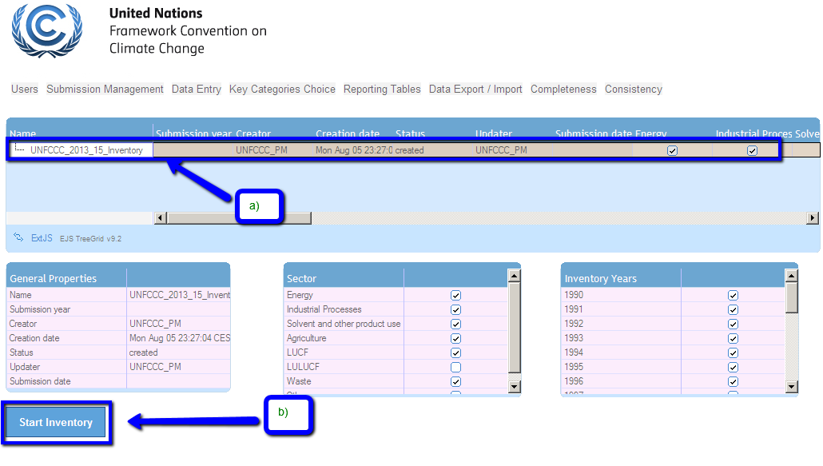

Figure 57. Work on Inventories screen – Status = Started

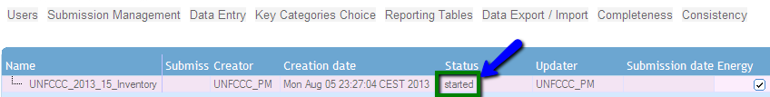

10.3 Send for checking (PM)

Once the SE’s/or PM’s have prepared the national GHG inventory, by entering data into the sectoral grids and the PM of the Party has checked the complete GHG inventory for consistency and correctness, the following steps allows the PM to send the inventory for checking:

- Log in as PM.
- Click on “View Inventories Progress” under sub menu “Submission Management”.
- The “View Inventories Progress” screen appears.
- Select the appropriate inventory by clicking the Inventory name under column “Name” (figure 58a).
- Press the “Send for Checking by NFP” button to send it to the NFP for his review and approval (figure 58b).
*** Note: A notification email will be sent to the NFP email address, and the status changed to “check” (figure 59).

Figure 58. Work on Inventories screen – Status = Started
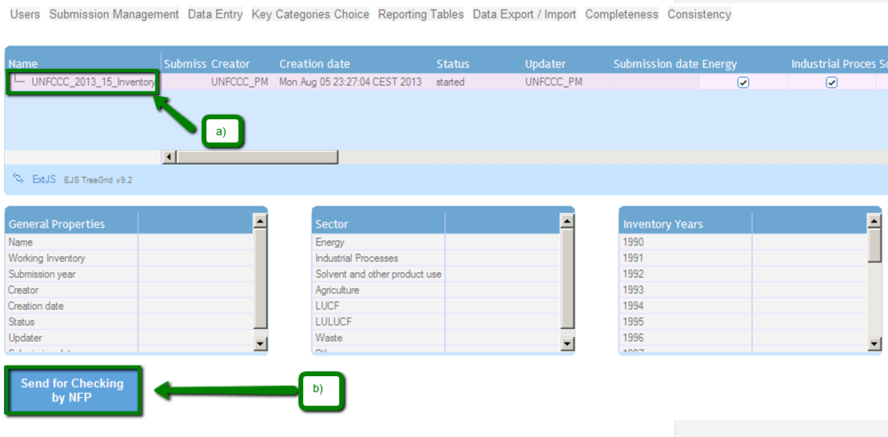

Figure 59. Work on Inventories screen – Status = check
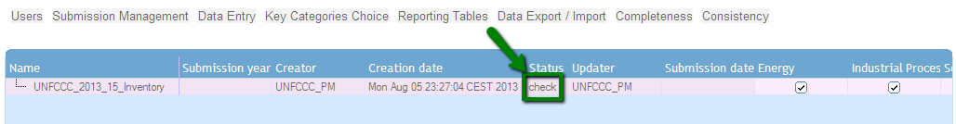

10.4 Send for approval/rejection of an Inventory (PM)

This section describes on how the PM approves or rejects an inventory after being checked by the PM.

10.4.1 Send for approval of an Inventory

- Log in as PM.
- Click on “View Inventories Progress” under sub menu “Submission Management”.
- The “View Inventories Progress” screen appears.
- Select the appropriate inventory by clicking the Inventory name under column “Name” (figure 60a).
- Press the “Send for Approval” button to send it to NFP for his/her review and approval of the inventory (figure 60b).

*** Note: A notification email will be sent to the PM, once the “Send for Approval” has been pressed. And the status changed to “Awaiting_approval” (figure 61).

Figure 60. Work on Inventories screen – Send for Approval - Status = check
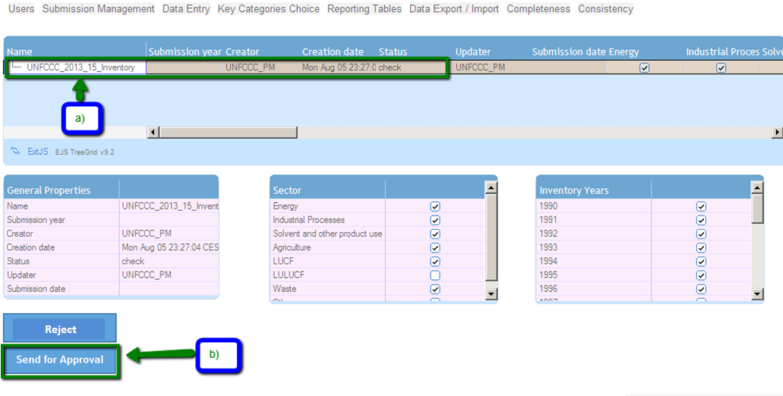

Figure 61. Work on Inventories screen – Status = awaiting_approval

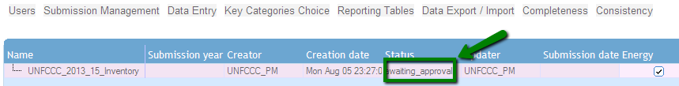

10.4.2 Rejection of an Inventory

- Log in as PM.
- Click on “View Inventories Progress” under sub menu “Submission Management”.
- The “View Inventories Progress” screen appears.
- Select the appropriate inventory by clicking the Inventory name under column “Name” (figure 62a).
- Press the “Reject” button (figure 62b).

*** Note: A notification email will be sent to the PM, once the “Reject” button has been pressed. And the status changed to “Awaiting_rejection_check” (figure 63).

Figure 62. Work on Inventories screen –Reject - Status = check
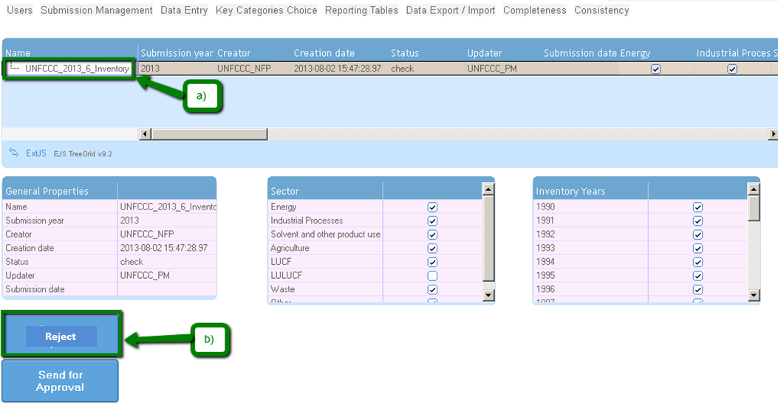

Figure 63. Work on Inventories screen – Propose Rejection - Status = awaiting_rejection_check

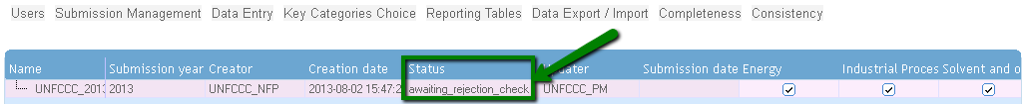

10.5 Approval or Rejection of an inventory (NFP)

This section describes on how the NFP approves or rejects an inventory after being sent for approval by the PM
(See section 10.4)

10.5.1 Approval of an inventory

- Log in as NFP.
- Click on “View Inventories Progress” under sub menu “Submission Management”.
- The “View Inventories Progress” screen appears.
- Select the appropriate inventory by clicking the Inventory name under column “Name” (figure 64).
- Press the “Approve” button (figure 64b).

Once the “Approve” button was pressed, the status of the selected inventory changes to “approved” (figure 65b).

*** Note: A notification email will be sent to the PM that the inventory has been approved. Therefore, the PM may proceed to selecting the tables for preparing the official submission. See section 10.6.

Figure 64. Work on Inventories screen – Approve an inventory - Status = awaiting_approval

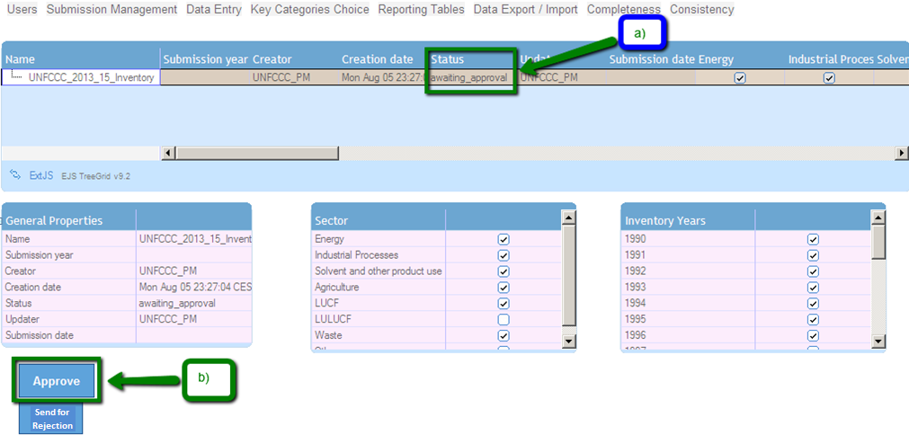

Figure 65. Work on Inventories screen – Approve an inventory - Status = approved
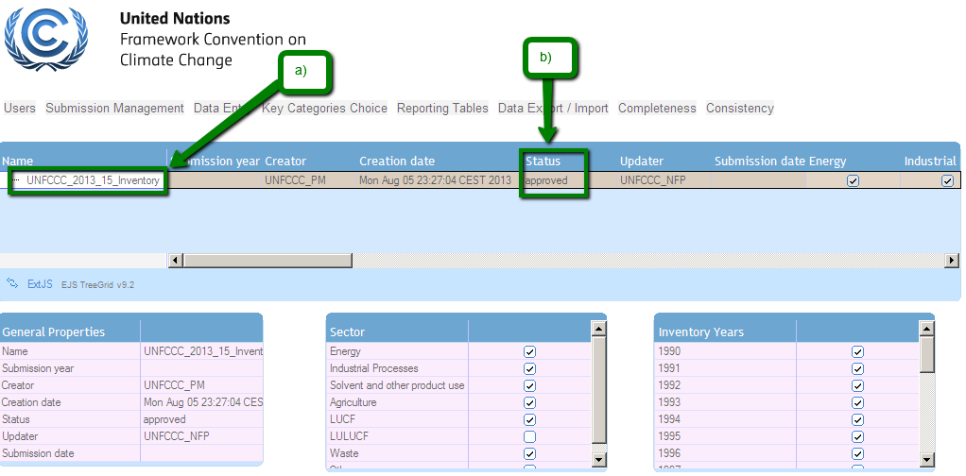

10.5.2 Rejection of an inventory

- Log in as NFP.
- Click on “View Inventories Progress” under sub menu “Submission Management”.
- The “View Inventories Progress” screen appears.
- Select the appropriate inventory by clicking the Inventory name under column “Name” (figure 66).
- Press the “Send for Rejection” button (figure 66b).

Once the “Send for Rejection” button was pressed, the status of the selected inventory changes to “awaiting_rejection” (figure 67a).

*** Note: A notification email will be sent to the PM that the inventory has been rejected. Therefore, the PM will be able to reject the submission. Proceed to section 10.4.2.

Figure 66. Work on Inventories screen – Rejection of an inventory - Status = awaiting_approval

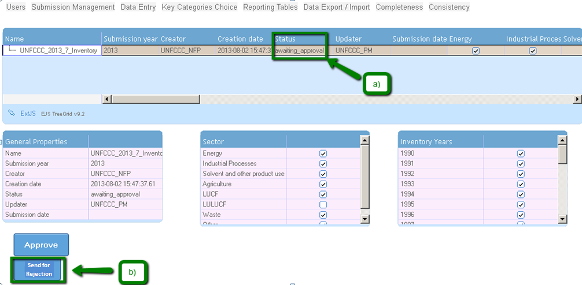

Figure 67. Work on Inventories screen – Rejection of an inventory - Status = rejected_approval

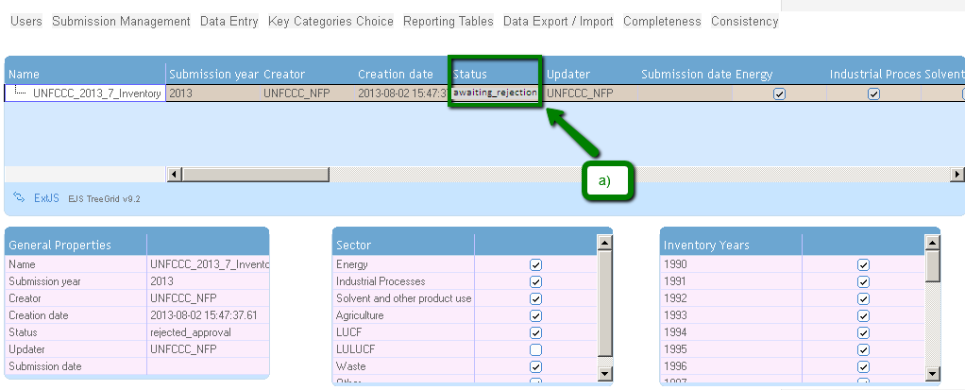

10.6 Submit inventory (PM)

This section describes on how the PM submits the inventory by selecting tables for the general submission after being approved by the NFP. (See section 10.5)

10.6.1 Submit select tables for preparing the general submission

- Log in as PM.
- Click on “View Inventories Progress” under sub menu “Submission Management”.
- The “View Inventories Progress” screen appears.
- Select the appropriate inventory by clicking the box under column “Working inventory” (figure 68a).
*** Note: The selected inventory year to be submitted should be in status “approved”
- Click on “Work on Inventories” under Submission Management (figure 68c).
This opens the Submit Inventory initial screen (figure 69).

- Click the inventory year to be submitted (figure 69 a).
- Press the “Generate Official Submission” button (figure 69c).

Figure 68. View Inventories Progress screen – select inventory for the preparation for the general submission
c

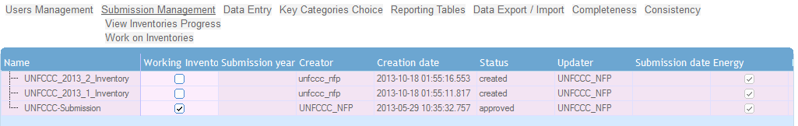
b
a

Figure 69. Submit select tables for the preparation for the general submission
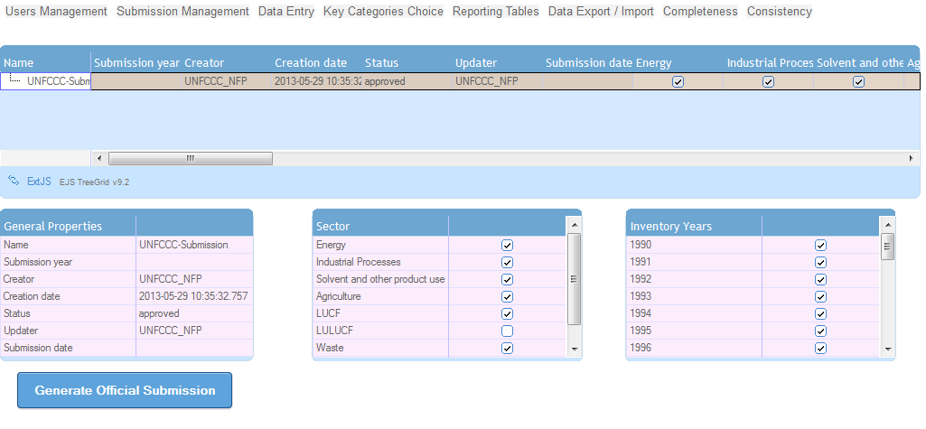
b
c
a

Once the “Generate Official Submission” button has been pressed the “Submit Inventory” initial screen for selecting the tables appears (figure 70).

- Select or deselect by clicking the appropriate year(s) under “Inventory Years” box (figure 70c) or the sector grids under the “Table” box (figure 70d) to generate the official submission.
- Press the “Submit” button (figure 70e). An official submission will be generated in the NAIIS system.

Figure 70. Submit – select tables and grids for the general submission
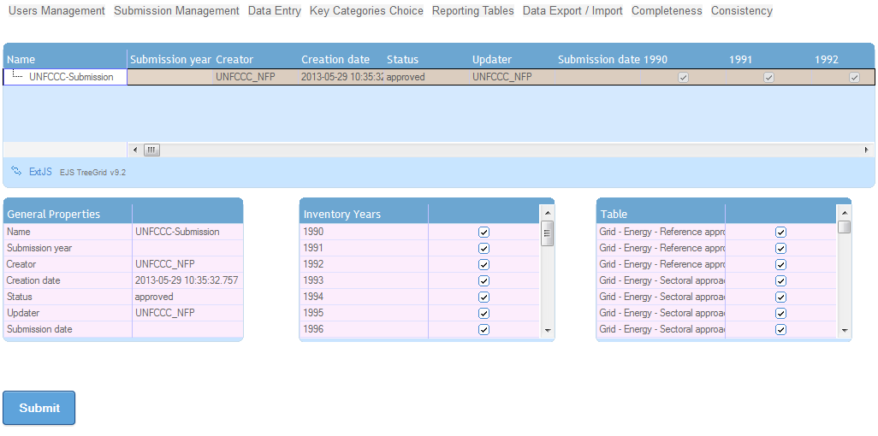
c
b
a
e
d

Glossary of terms and abbreviations

AD – Activity Data
AWMS – Animal Waste Management System
BOD – Biochemical Oxygen Demand
C – Carbon
C₂F₆ – Hexafluoroethane
CF₄ – Tetrafluoromethane
CH₄ – Methane
CO – Carbon Monoxide
CO₂ – Carbon dioxide
COD – Chemical Oxygen Demand
dm – dry matter
Gg – Gigagram
ha – hectare
HFC – Hydrofluorocarbon
hl – hectolitre
k – kilo
kg – kilogram
kha – kilo hectare
kt – kilotonne
LTO – Landing/Take Off
LUCF – Land-Use Change and Forestry
LULUCF – Land Use, Land-Use Change and Forestry
m³ – cubic meter
MCF – Methane Correction Factor
Mg – Megagram
Mha – Megahectare
MSW – Municipal Solid Waste
N – Nitrogen
N₂O – Nitrous Oxide
NFP – National Focal Point
NH₃ – Ammonia
NMVOC – Non-Methane Volatile Organic Compound
NO_{X} – Nitrogen Dioxide
PFC – Perfluorocarbon
RA - Reference Approach
SE – Sectoral Expert
SF₆ – Sulphur Hexafluoride
SO₂ – Sulphur Dioxide
SWDS – Solid Waste Disposal Site
t – tonne
Tg – Teragram
TJ – Terajoules
XML – Extensible Markup Language
year t – inventory year

Annex 1: Non-Annex I (NAI) Parties

- Afghanistan | AFG
- Albania | ALB
- Algeria | DZA
- Andorra | AND
- Angola | AGO
- Antigua and Barbuda | ATG
- Argentina | ARG
- Armenia | ARM
- Azerbaijan | AZE
- Bahamas | BHS
- Bahrain | BHR
- Bangladesh | BGD
- Barbados | BRB
- Belize | BLZ
- Benin | BEN
- Bhutan | BTN
- Bolivia | BOL
- Bosnia and Herzegovina | BIH
- Botswana | BWA
- Brazil | BRA
- Brunei Darussalam | BRN
- Burkina Faso | BFA
- Burundi | BDI
- Cambodia | KHM
- Cameroon | CMR
- Cape Verde | CPV
- Central African Republic | CAF
- Chad | TCD
- Chile | CHL
- China | CHN
- Colombia | COL
- Comoros | COM
- Congo | COG
- Cook Islands | COK
- Costa Rica | CRI
- Cote d’Ivoire | CIV
- Cuba | CUB
- Democratic People’s Republic of Korea | PRK
- Democratic Republic of the Congo | COD
- Djibouti | DJI
- Dominica | DMA
- Dominican Republic | DOM
- Ecuador | ECU
- Egypt | EGY
- El Salvador | SLV
- Equatorial Guinea | GNQ
- Eritrea | ERI
- Ethiopia | ETH
- Fiji | FJI
- Gabon | GAB
- Gambia | GMB
- Georgia | GEO
- Ghana | GHA
- Grenada | GRD
- Guatemala | GTM
- Guinea | GIN
- Guinea-Bissau | GNB
- Guyana | GUY
- Haiti | HTI
- Honduras | HND
- India | IND
- Indonesia | IDN
- Iran (Islamic Republic of) | IRN
- Iraq | IRQ
- Israel | ISR
- Jamaica | JAM
- Jordan | JOR
- Kazakhstan | KAZ
- Kenya | KEN
- Kiribati | KIR
- Kuwait | KWT
- Kyrgyzstan | KGZ
- Lao People's Democratic Republic | LAO
- Lebanon | LBN
- Lesotho | LSO
- Libya | LBY
- Liberia | LBR
- Madagascar | MDG
- Malawi | MWI
- Malaysia | MYS
- Maldives | MDV
- Mali | MLI
- Marshall Islands | MHL
- Mauritania | MRT
- Mauritius | MUS
- Mexico | MEX
- Micronesia (Federated States of) | FSM
- Mongolia | MNG
- Montenegro | MNE
- Morocco | MAR
- Mozambique | MOZ
- Myanmar | MMR
- Namibia | NAM
- Nauru | NRU
- Nepal | NPL
- Nicaragua | NIC
- Niger | NER
- Nigeria | NGA
- Niue | NIU
- Oman | OMN
- Pakistan | PAK
- Palau | PLW
- Panama | PAN
- Papua New Guinea | PNG
- Paraguay | PRY
- Peru | PER
- Philippines | PHL
- Qatar | QAT
- Republic of Korea | KOR
- Republic of Moldova | MDA
- Rwanda | RWA
- Saint Kitts and Nevis | KNA
- Saint Lucia | LCA
- Saint Vincent and the Grenadines | VCT
- Samoa | WSM
- San Marino | SMR
- Sao Tome and Principe | STP
- Saudi Arabia | SAU
- Senegal | SEN
- Serbia | SRB
- Seychelles | SYC
- Sierra Leone | SLE
- Singapore | SGP
- Solomon Islands | SLB
- Somalia | SOM
- South Africa | ZAF
- South Sudan | SSD
- Sri Lanka | LKA
- Sudan | SDN
- Suriname | SUR
- Swaziland | SWZ
- Syrian Arab Republic | SYR
- Tajikistan | TJK
- Thailand | THA
- The former Yugoslav Republic of Macedonia | MKD
- Timor-Leste | TLS
- Togo | TGO
- Tonga | TON
- Trinidad and Tobago | TTO
- Tunisia | TUN
- Turkmenistan | TKM
- Tuvalu | TUV
- Uganda | UGA
- United Arab Emirates | ARE
- United Republic of Tanzania | TZA
- Uruguay | URY
- Uzbekistan | UZB
- Vanuatu | VUT
- Venezuela | VEN
- Viet Nam | VNM
- Yemen | YEM
- Zambia | ZMB
- Zimbabwe | ZWE

Annex 2: Fuel categories

Liquid Fuels (Crude oil and petroleum products)
Crude oil
Orimulsion
Natural gas liquids
Gasoline
Motor Gasoline
Aviation Gasoline
Jet Gasoline
Jet kerosene
Other kerosene
Shale oil
Gas/Diesel oil
Residual fuel oil
Liquefied petroleum gas
Ethane
Naphtha
Bitumen
Lubricants
Petroleum coke
Refinery Feedstock
Other oil
Refinery gas
Paraffin waxes
White spirit
Heavy fuel - low
Heavy fuel - medium
Heavy fuel - high
Light fuel oil/diesel - low
Light fuel oil/diesel - medium
Light fuel oil/diesel - high
Diesel (road)
Gasoline (road)

Solid Fuels (Coal and coal products)
Anthracite
Coking coal
Other bituminous coal
Sub-bituminous coal
Other sub-bituminous coal
Lignite/brown coal
Oil shale

Peat
Coke
Coke oven coke
Gas coke
Patent fuel
Coke
Coke oven coke
Gas coke
BKB/Patent Fuel
Patent Fuel
Brown coal briquettes
Gas works gas
Coke oven gas
Blast furnace gas
Other gases and mixtures from coal-derived carbon
Coal - low
Coal - medium
Coal - high

Gaseous Fuels
Natural gas

Other Fuels
Municipal solid waste
Industrial waste
Fuel mixtures (fossil and biomass)
Waste gas
Other wastes
Hydrogen

Biomass
Solid
Wood/Wood waste
Agricultural waste
Charcoal
Other solid biomass

Liquid
Bio-alcohol
Sulphur lies (Black liquor)
Sewage sludge
Other liquid biomass

Gas
Landfill gas
Sludge gas (sewage gas)
Other biogas

Annex 3: Global Warming Potentials (GWPs)

Greenhouse gas | Chemical formula | 1995 IPCC GWP
Carbon dioxide | CO₂ | 1
Methane | CH₄ | 21
Nitrous oxide | N₂O | 310
HFC-23 | CHF₃ | 11,700
HFC-32 | CH₂F₂ | 650
HFC-41 | CH₃F | 150
HFC-43-10mee | C₅H₂F₁₀ | 1,300
HFC-125 | C₂HF₅ | 2,800
HFC-134 | C₂H₂F₄ | 1,000
HFC-134a | CH₂FCF₃ | 1,300
HFC-152a | C₂H₄F₂ | 140
HFC-143 | C₂H₃F₃ | 300
HFC-143a | CF₃CH₃ | 3,800
HFC-227ea | C₃HF₇ | 2,900
HFC-236fa | C₃H₂F₆ | 6,300
HFC-254ca | C₃H₃F₅ | 560
Perfluoromethane | CF₄ | 6,500
Perfluroethane | C₂F₆ | 9,200
Perfluoropropape | C₃F₈ | 7,000
Perfluorobutane | C₂F₁₀ | 7,000
Perfluorocyclobutane | c-c₄F₈ | 8,700
Perfluoropentane | C₅F₁₂ | 7,500
Perfluorohexane | C₆F₁₄ | 7,400
Sulphur hexafluoride | SF₆ | 23,900
Source: Climate Change 1995, The Science of Climate Change: Summary for Policymakers and Technical Summary of the Working Group I Report, page 22.

Annex 4: Default values

- Fraction of carbon stored for reference approach
Bitumen – 1
Coal oils and tars (from coking coal – 0.75
Ethane – 0.8
Gas/Diesel oil – 0.5
LPG – 0.8
Lubricants – 0.5
Naphtha – 0.8
Natural gas – 0.33

- Conversion factors
  - CH₄ volume CH₄ Gg = 0.67
  - Conversion factors for energy
From | To | Multiply by
J | TJ | 10⁻¹²
KJ | TJ | 10⁻⁹
MJ | TJ | 10⁻⁶
GJ | TJ | 10⁻³
TJ | TJ | 1
cal | TJ | 4.1868 x 10⁻¹²
kcal | TJ | 4.1868 x 10⁻⁹
Mcal | TJ | 4.1868 x 10⁻⁶
Gcal | TJ | 4.1868 x 10⁻³
Tcal | TJ | 4.1868
kWh | TJ | 3.6 x 10⁻⁶
MWh | TJ | 3.6 x 10⁻³
GWh | TJ | 3.6
Btu | TJ | 1.0551 x 10⁻⁹
kBtu | TJ | 1.0551 x 10⁻⁶
MBtu | TJ | 1.0551 x 10⁻³
GBtu | TJ | 1.0551
toe | TJ | 41.868 x 10⁻³
ktoe | TJ | 41.868
Mtoe | TJ | 4.1868 x 10⁴
TJ | J | 10¹²
TJ | KJ | 10⁹
TJ | MJ | 10⁶
TJ | GJ | 10³
TJ | cal | 238.8 x 10⁹
TJ | kcal | 238.8 x 10⁶
TJ | Mcal | 238.8 x 10³
TJ | Gcal | 238.8
TJ | Tcal | 238.8 x 10⁻³
TJ | kWh | 277.8 x 10³
TJ | MWh | 277.8
TJ | GWh | 277.8 x 10⁻³
TJ | Btu | 947.8 x 10⁶
TJ | kBtu | 947.8 x 10³
TJ | MBtu | 947.8
TJ | GBtu | 947.8 x 10⁻³
TJ | toe | 23.88
TJ | ktoe | 23.88 x x 10⁻³
TJ | Mtoe | 23.88 x 10⁻⁶

- Emission factors
  - Ozone precursors and SO₂ from oil refining – Crude oil throughput
NOx = 0.06
CO = 0.09
NMVOC = 0.62
SO₂ = 0.93
  - Ozone precursors and SO2 from oil refining – Catalytic cracker throughput
NOx = 0.2
CO = 42.6
NMVOC = 0.6
SO₂ = 1.5
  - NMVOC emissions from storage and handling – Crude oil throughput
Secondary seals = 0.2
Primary seals = 0.7
Fixed Roof = 4.9
  - SO₂ from Sulphur Recovery Plants – 139 kg/t

- CKD correction factor = 1.02

- Methane Correction Factor (MCF)
Managed — 1.0
Unmanaged – deep (>= 5m) — 0.8
Unmanaged – shallow (< 5m) — 0.4
Methane Correction Factor — 0.6

- Inventory time period (for Cropland remaining Cropland – Carbon stock change – Mineral soils) = 20 years

Good Practice Guidance and Uncertainty Management in National Greenhouse Gas Inventories, 2000, and Good Practice Guidance for Land Use, Land-Use Change and Forestry, 2003.
http://unfccc.int/files/national_reports/non-annex_i_natcom/training_material/methodological_documents/application/zip/unfccc_nai_is_132.zip

